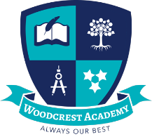
Woodcrest Academy
Uniforms

Item | Colour
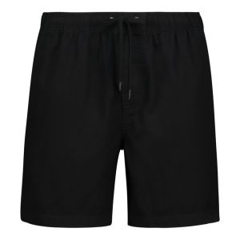  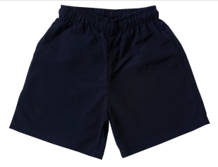  Shorts | Navy blue
Golfer  Can be purchased from Peps, Pick n Pay, Gems school wear.  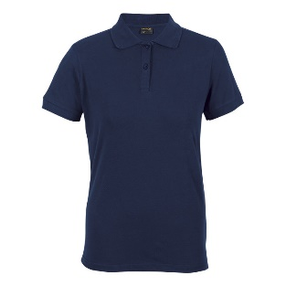  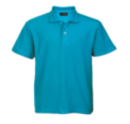  School uniform shirts are purchased from Cindy at Umkomaas Sewing 0827670164. | Barron Surf Blue  (Grade RRR-6)  Barron Golfer Navy  (Grade 7,8,9)
Socks and shoes  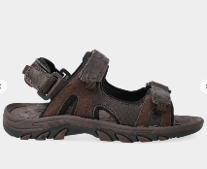  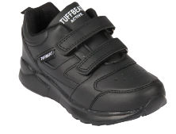 | Plain Black, Brown or Navy Shoes. Sandals must have a back strap.  Worn with navy blue socks.
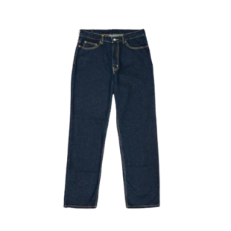  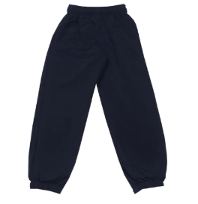  Pants  Plain navy pants, plain navy loose-fitting jeans. | Navy blue
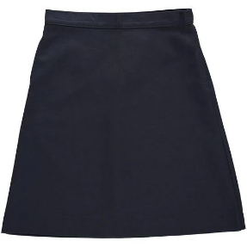  Girls’ skirt  Navy skirt or culottes.  (No short skirts.) | Navy blue
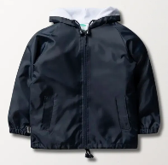  Anorak, jacket or jersey  School badge embroidery on jackets and school shirts is done by Cindy at Umkomaas  Sewing 0827670164. | Navy blue

